双流某重点小学二年级上学期英语期末试题
班级_____________ 姓名 ____________ 得分______________

听力部分 (40分)

一、听录音，圈出你所听到的图片。(20分)

  - A.  B.  2. A.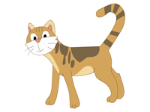 B. 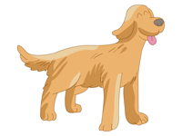

- A. 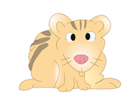 B. 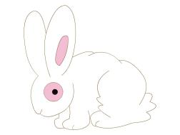 4. A.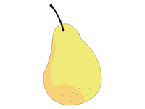B. 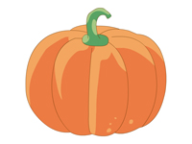

二、听录音，圈出你所听到的单词。（10分）
1. A. cousin B. aunt
2. A. short B. long
3. A. rubber B. rabbit
4. A. monkey B. giraffe
5.A. potato B.pumpkin
三、听录音，圈出你所听到的句子。（10分）
( ) 1. A. She is my cousin. B. Is she your cousin?
( ) 2. A. I have a hamster. B. I have a rabbit.
( ) 3. A. It has a long neck. B. It has a short tail.
( ) 4. A. These are oranges. B. Those are pumpkins.
( ) 5. A. What are these? B. What is this?

笔试部分（60分）

四、根据图片圈出正确的单词。（10分）

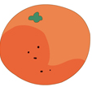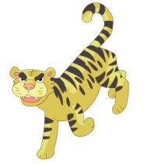
peach apple short tiger pear
apple orange tall lion pumpkin

五、圈出不同类的单词。（10分）
( ) 1. A. mum B. dad C. uncle D. he
( ) 2.A. orange B. apple C. potato D. pear
( ) 3. A. tiger B.monkey C. zoo D. giraffe
( ) 4. A. big B. Red C. yellow D. brown
( ) 5. A.long B. tail C. short D. big

六、根据图片圈出正确的句子。（10分）

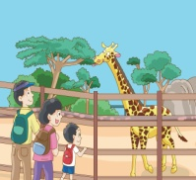 1. A. Look at the giraffe. B. Look at the monkey.
 2. A. She is tall. B. She is short.
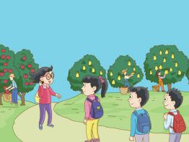 3. A. Those are pears. B. These are apples.
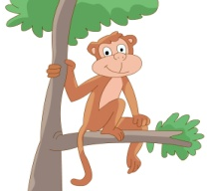 4. A. It has a short tail. B. It has a long tail.
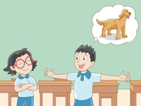 5. A. I have a dog. B. I have a cat.

七、将下列单词归类。（10分）
rabbit red aunt monkey cousin
yellow short pears oranges long

1. white _________________________
2.apples _________________________
3.uncle __________________________
4.big ____________________________
5.tiger __________________________

八、情景选择（20分）
（ ）1. 你想告诉别人这是你表妹，你说：
A. This is my cousin.
B. This is my aunt.
C. She is my cousin.
（ ）2. 你想知道远处那些是什么，你问：
A. What are these?
B. What are those?
C. What is that?
（ ） 3. 你想告诉别人你有一只仓鼠，你说：
A. I have a hamster.
B. I have a dog.
C. You have a hamster.
（ ）4. 你想告诉别人那些是土豆，你说：
A. These are pumpkins.
B. Those are potatoes.
C. That is a potato.
（ ）5. 你想说猴子有一条长尾巴，你说：
A. The monkey has a long tail.
B. The bear has a short tail.
C. It has a long tail.
听力材料

一、听录音，圈出你所听到的图片。(20分)
1. This is Wang Bing.
2. A dog.
3. A rabbit.
4. A pumpkin.

二、听录音，圈出你所听到的单词。（10分）
1. cousin
2. short
3. rabbit
4. monkey
5. pumpkin

三、听录音，圈出你所听到的句子。（10分）
1. Is she your cousin?
2. I have a hamster.
3. It has a short tail.
4. These are oranges.
5. What is this?

